**CHAPTER 1**

**INTRODUCTION**

**1.1 INTRODUCTION**

A robot can be defined as a programmable, self-controlled device consisting of electronic, electrical, or mechanical units. More generally, it is a machine that functions in place of a living agent. Robots are especially desirable for certain work functions because, unlike humans, they never get tired; they can work in physical conditions that are uncomfortable or even dangerous; they can operate in airless conditions; they do not get bored by repetition; and they cannot be distracted from the task at hand. The robot is powerful, reliable and can be use in hot temperature area where a human after working for so long can become sick and exhausted. This project will introduce a new era in industries to use automated machine and robot for more precise, cost effective and reliable work. The most apparent reasons that are associated in installing of robotic systems in industries are:

1) Saving of manpower.

2) Improved quality & efficiency.

3) Ability to work in any hostile environment.

4) Increased consistency & flexibility.

5) Increased yields and reduced wastage.

In this model of robot power supply used is it’s own and could be mobilized. The sole purpose of micro controller based robot was to propose a design that introduces the idea of automation in industries. The idea is to reduce manual controlled system, which always needed a human interface. This Robotic system is feasible by small and local industries having small scale production. The system is a reliable, can reduce the cost of production, and reduce the manpower and human workload.

**1.2 Applications**

Extensive applications in hazardous conditions such as Minefield diffusing, Testing of explosives, Handling of inflammatory materials in industrial automation, To transport resources during flood or border front.

**Medical Applications:** These robots can be used in various surgical operations like in joint replacement operations, orthopedic and internal surgery operations. They perform the operations with more precision and accuracy.

**Industrial Applications**: These robots are used in manufacturing segments to pick up the required parts and place them in correct positions to complete the machinery fixture. They can also be used to place objects on a conveyer belt as well as to pick up defective products from the conveyer belt.

**Defense Applications:** They can be used for robot performed military applications such as surveillance and also to pick up harmful objects like bombs and diffuse them safely. To pull out casualties

**Space exploration:** Locating faults and mechanical operations like fitting, connecting joints etc.

**Disaster management:** Rescuing people in fire accidents, floods and earth quakes.

**CHAPTER 2**

**LITERATURE SURVEY**

**2.1 Available controlling systems**

An almost endless variety of computers can be used as a robot’s brain. The most common types used are:

* Microcontroller:- Microcontrollers are the preferred method for endowing a robot with smarts. The reasons for this include their low costs, simple power requirements (usually 2.5 to 5 V), and ability of most, to be programmed using software and a simple hardware interface on the PC. Once programmed, the microcontroller is disconnected from the PC and operates on its own. These are programmed either in an assembly language or in a high level language such as BASIC or C. There are literally hundreds of different microcontrollers with an excess of different interfacing capabilities that you can choose from, to control the robot.
* Personal Digital Assistant (PDA) :- PDA provides a lot of processing power in a fairly small space with a number of features that make it very attractive for use as a robot controller. Personal digital assistants can be used as a small robot controller that combines many of the advantages of microcontrollers, larger single-board computers, and PC motherboards and laptops. The built-in power supply and graphic LCD display (with Graffiti stylus input) are further advantages, eliminating the need for supplying power to the PDA. The most significant issue that will be encountered using a PDA as a robot controller is deciding how to interface it to the robot’s electronics. PDAs are becoming increasingly popular as robot controllers and there are a variety of products and resources that will make the effort easier.
* Single-board computer:- A few years ago, complete computer systems built on a PCB were the preferred method of controlling robots. These systems are still used but are much less popular due to the availability of low-cost PC motherboards and more powerful, easy to use microcontrollers. There are a number of robots that are controlled by single-board computers or SBCs. Like microcontrollers, an SBC can be programmed in either assembly language or in a high-level language such as BASIC or C and contain not only the processor and the memory but also the I/O interfaces necessary to control a robot. SBCs avoid the programming issues of microcontrollers due to the built-in RS-232 or Ethernet interfaces, which allow simple application transfers.
* Personal computer motherboards and laptops:- Very small form factor PC motherboards and laptops are common controllers for larger robots. Having your personal computer control your robot is a good use of available resources, because you already have the computer to do the job. Just because the average PC is deskbound it doesn’t mean it can’t mount it on the robot and use it in a portable environment. These controllers can be programmed using standard development tools and commercial, digital I/O add-ons, for the interfaces needed for the different robot functions. 2.1.2 Vision systems.
* Sensor based vision:- This is the most widely used method in robot construction. Because it is portable, low cost, fast to process and has a variety of forms that can be chosen from.
* Video vision:- Single- and multicell-vision systems are useful for detecting the absence or presence of light, but they cannot make out the shapes of objects. This greatly limits the environment into which such a robot can be placed. By detecting the shape of an object, a robot may be able to make intelligent assumptions about its surroundings and perhaps, be able to navigate those surroundings. A video system for robot vision need not be overly sophisticated. The resolution of the image can be as low as about 100 by 100 pixels (10,000 pixels total), though a resolution of no less than 300 by 200 pixels (60,000 pixels total) is preferred. The higher the resolution is, the better the image and therefore the greater the robot’s ability to discern shapes. Video systems that provide a digital output are generally easier to work with than those that provide only an analog video output. You can connect digital video systems directly to a PC, such as through a serial, parallel, or USB port. Analog video systems require that a video capture card, a fast analog to digital converter, or some similar device to be attached to the robot’s computer. While the hardware for video vision is now affordable to most robot builder, the job of translating a visual image a robot can use, requires high-speed processing and complicated computer programming. Giving robots the ability to recognize shapes has proved to be a difficult task. Consider the static image of a doorway. Our brains easily comprehend the image, adapting to the angle at which we are viewing the doorway; the amount, direction, and contrast of the light falling on it; the size and kind of frame used in the doorway; whether the door is open or closed; and hundreds or even thousands of other variations. Robot vision requires that each of these variables be analyzed, a job that requires computer power and programming complexity beyond the means of most robot experimenters.

**2.2 Scope of the Project**

The forklift prototype is a four-wheeled that has the ability to follow the direction guided by the operator. There are four wheels including two driving wheels controlled by two motors and two free wheels in front that is able to rotate 360°. With four wheels, both driving wheels are always in contact with the surface. This project consists of four main stages, which are theoretical design, mechanical fabrication, electronic hardware design.

**2.3 Market Survey**

A market survey is an important requirement for initiating any successful business. The objective of a market survey is to collect information on various aspects of the business. This survey is a tool through which we can minimize risk. After the market survey, the results must be analyzed in order to finalize a business plan. We are implementing manually guided vehicle, which replaces the normal transporting methods. So that we wants to consider all the sections related to this works such as problems arising while installing. So we conducted a market survey by personnel interview techniques was used with the measure emphasis on personal interview method. Interviews were conducted through the structure questionnaire, Also we go through people who work in large industries such as production plant, supply station etc.

Our gesture controlled robot works on principle of accelerometer which records hand movements and sends that data to microcontroller which sends that data to wireless transmitter. This information is transmitted through XBee module.

On receiving side, received information is transferred to microcontroller by XBee module. Microcontroller takes various decisions based on received information.

These decisions are passed to motor driver IC which triggers the motors in different configuration to make the robot move accordingly.

We divided our task into two parts to make task easy, simple and to avoid complexity

The first is transmitting section, which include following components:

* Accelerometer
* Microcontroller
* XBee Tx

The second is receiving which include following components:

* XBee Rx
* Microcontroller
* Motor driver
* Dc motors

Assuming, the ratio of the dead weight to the payload of material handling equipment is minimum. Material handling is designed for safe transportation. Due to globalization of the economies of many countries, companies all over the world are making efforts to further expand their business areas. So the need for container transportation is being increased, and container terminals should satisfy such needs. For example, container terminals should provide better services to meet needs, should handle materials more speedily, and should reduce the cost. Since there are the same needs in other countries as well, the 365-day 24-hour operable container terminals should be constructed. To meet the above-described needs, companies should establish. A mixture of material handling systems is in the use, exact from that entirely physical to the ones that are semi-automatic but manually controlled. The factors considered are:

* Volume to be handled
* High speed behavior
* Efficiency
* Product kind such as, shape, size, weight etc.
* Character of the item for consumption (perishable, crushable, hazardous etc.)

**CHAPTER 3**

**DESIGN AND WORKING**

**Block Diagram**

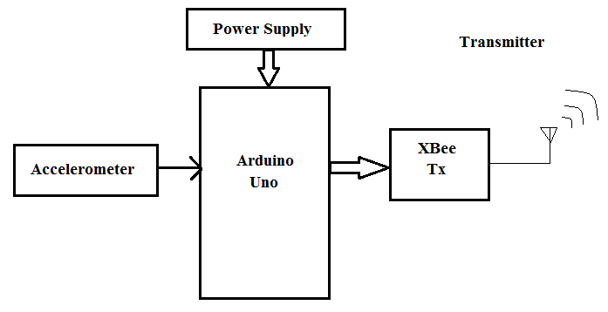

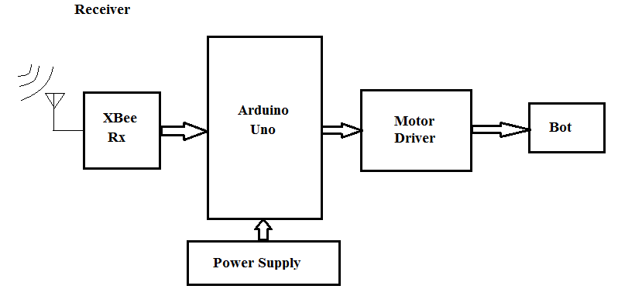

### Fig 3.1 Block Diagram of system

**3.1 Accelerometer**

The ADXL335 is a small, thin, low power, complete 3-axis accelerometer with signal conditioned voltage outputs. The product measures acceleration with a minimum full-scale range of ±3 g. It can measure the static acceleration of gravity in tilt-sensing applications, as well as dynamic acceleration resulting from motion, shock, or vibration. The user selects the bandwidth of the accelerometer using the CX, CY, and CZ capacitors at the XOUT, YOUT, and ZOUT pins. Bandwidths can be selected to suit the application with a range of 0.5 Hz to 1600 Hz for the X and Y axes, and a range of 0.5 Hz to 550 Hz for the Z axis. The ADXL335 is available in a small, low profile, 4 mm × 4 mm × 1.45 mm, 16-lead, plastic lead frame chip scale package (LFCSP_LQ).

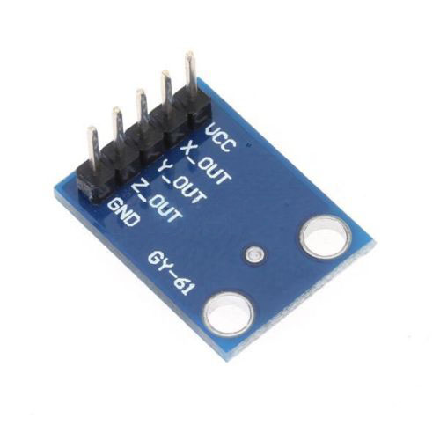

**Fig 3.2 Accelerometer[9]**

**3.2 XBee Module**

The XBee module is used between the controller and robot. XBee Modules are available in two form-factors; Through-Hole and Surface Mount. All XBee (with the exception of the XBee 868LP) are available in the popular 20-pin Through-Hole form-factor. Certain XBee modules are also available in a 37-pad Surface Mount design, which is popular for higher volume applications due to the reduced manufacturing costs of SMT technology.

XBee Modules typically come with several antenna options, including PCB Embedded, Wire, and RPSMA.

The XBee can operate either in a transparent data mode or in a packet-based application programming interface (API) mode. In the transparent mode, data coming into the Data IN (DIN) pin is directly transmitted over-the-air to the intended receiving radios without any modification. In API mode the data is wrapped in a packet structure that allows for addressing, parameter setting and packet delivery feedback, including remote sensing and control of digital I/O and analog input pins.

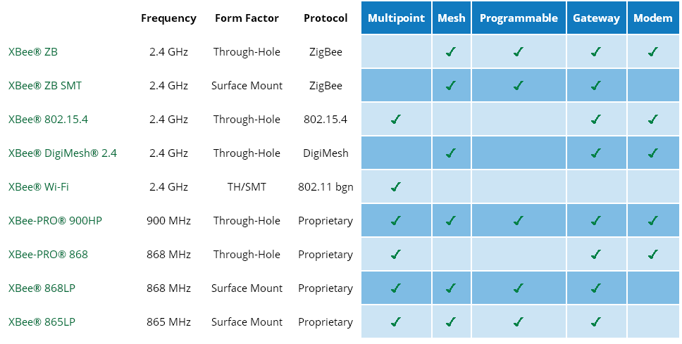

**Table no.3.1 Types of XBee and specification[11]**

**3.2.1 Features of XBee:**

* Common XBee footprint for a variety of RF modules.
* Fast 250 kbps RF data rate to the end node.
* 2.4 GHz for worldwide deployment.
* Sleep modes supported for extended battery life.

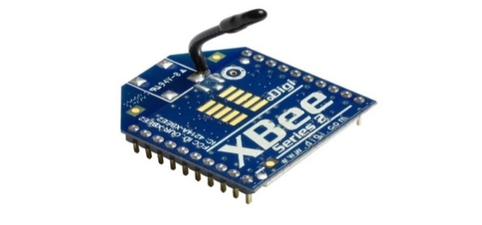

**Fig 3.3** **XBee Module[11]**

### 3.3 Microcontroller – Arduino Uno

The Arduino Uno is a microcontroller board based on the ATmega328 ([datasheet](http://www.atmel.com/dyn/resources/prod_documents/doc8161.pdf)). It has 14 digital input/output pins (of which 6 can be used as PWM outputs), 6 analog inputs, a 16 MHz ceramic resonator, a USB connection, a power jack, an ICSP header, and a reset button. It contains everything needed to support the microcontroller; simply connect it to a computer with a USB cable or power it with an AC-to-DC adapter or battery to get started.

The Uno differs from all preceding boards in that it does not use the FTDI USB-to-serial driver chip. Instead, it features the Atmega16U2 (Atmega8U2 up to version R2) programmed as a USB-to-serial converter.

* 1.0 pinout: added SDA and SCL pins that are near to the AREF pin and two other new pins placed near to the RESET pin, the IOREF that allow the shields to adapt to the voltage provided from the board. In future, shields will be compatible with both the board that uses the AVR, which operates with 5V and with the Arduino Due that operates with 3.3V. The second one is a not connected pin, is reserved for future purposes.
* Stronger RESET circuit.
* ATmega 16U2 replace the 8U2.

"Uno" means one in Italian and is named to mark the upcoming release of Arduino 1.0. The Uno and version 1.0 will be the reference versions of Arduino, moving forward. The Uno is the latest in a series of USB Arduino boards, and the reference model for the Arduino platform; for a comparison with previous versions, see the [index of Arduino boards](http://arduino.cc/en/Main/Boards).

**3.3.1 Power Supply**

The Arduino Uno can be powered via the USB connection or with an external power supply. The power source is selected automatically.

External (non-USB) power can come either from an AC-to-DC adapter or battery. Leads from a battery can be inserted in the GND and Vin pin headers of the POWER connector.

The board can operate on an external supply of 6 to 20 volts. If supplied with less than 7V, however, the 5V pin may supply less than five volts and the board may be unstable. If using more than 12V, the voltage regulator may overheat and damage the board. The recommended range is 7 to 12 volts.

The power pins are as follows:

* **Vin:** The input voltage to the Arduino board when it's using an external power source (as opposed to 5 volts from the USB connection or other regulated power source). You can supply voltage through this pin, or, if supplying voltage via the power jack, access it through this pin.
* **5V:** This pin outputs a regulated 5V from the regulator on the board. The board can be supplied with power either from the DC power jack (7 - 12V), the USB connector (5V), or the VIN pin of the board (7-12V). Supplying voltage via the 5V or 3.3V pins bypasses the regulator, and can damage your board.
* **3V3:** A 3.3 volt supply generated by the on-board regulator. Maximum current draw is 50 mA.
* **GND:** Ground pins.
* **IOREF:** This pin on the Arduino board provides the voltage reference with which the microcontroller operates. A properly configured shield can read the IOREF pin voltage and select the appropriate power source or enable voltage translators on the outputs for working with the 5V or 3.3V.

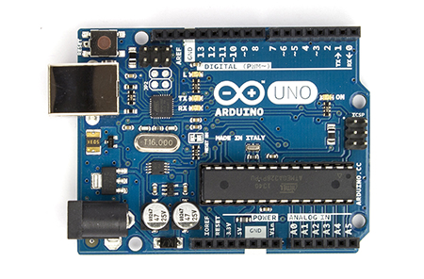

**Fig 3.4 Arduino Uno R3[10]**

**3.4 Motor Driver**

Generally, even the simplest robot requires a motor to rotate a wheel or performs particular action. Since motors require more current then the microcontroller pin can typically generate, you need some type of a switch (Transistors, MOSFET, Relay etc.,) which can accept a small current, amplify it and generate a larger current, which further drives a motor. This entire process is done by what is known as a **motor driver**.

Motor driver is basically a current amplifier which takes a low-current signal from the microcontroller and gives out a proportionally higher current signal which can control and drive a motor.

In this project, LM298 motor driver IC is used to build the circuit. It gives output current up to 2A which is required to drive the DC motors. Also to prevent the back EMF generated at the starting and stopping of motor 1N5818 diodes are used. It takes the input from the microcontroller in form of data bits and drives the motors as per the incoming data.

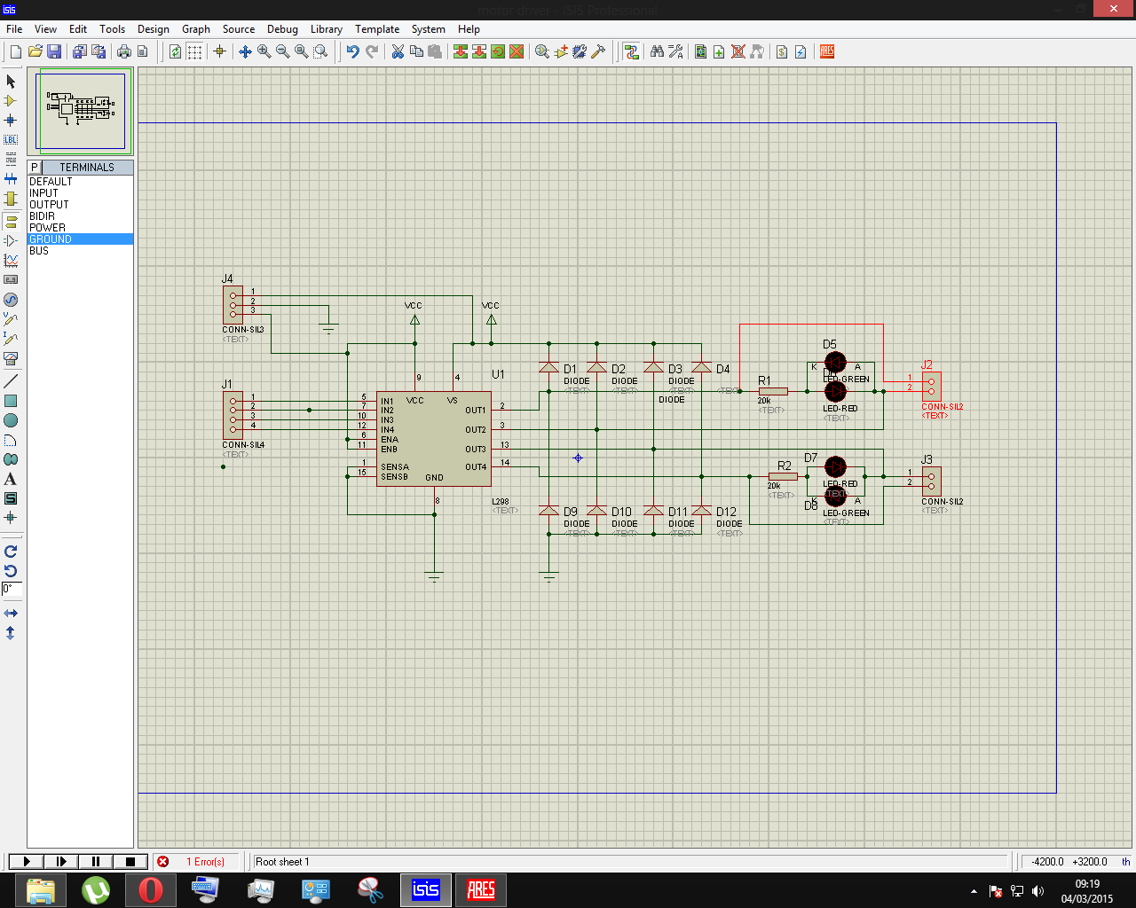

**Fig 3.5 Motor Driver Circuit Diagram**

**3.4.1 Features**

* Operating supply voltage up to 46 V .
* Total DC current up to 4 A
* Low saturation voltage
* Over temperature protection
* Logical "0" input voltage up to 1.5 V
* High noise immunity

The pin connections of PCB used in this project for motors is shown in figure below. LM298 motor driver IC, 1N5818 diodes are placed on the PCB in their respective positions.

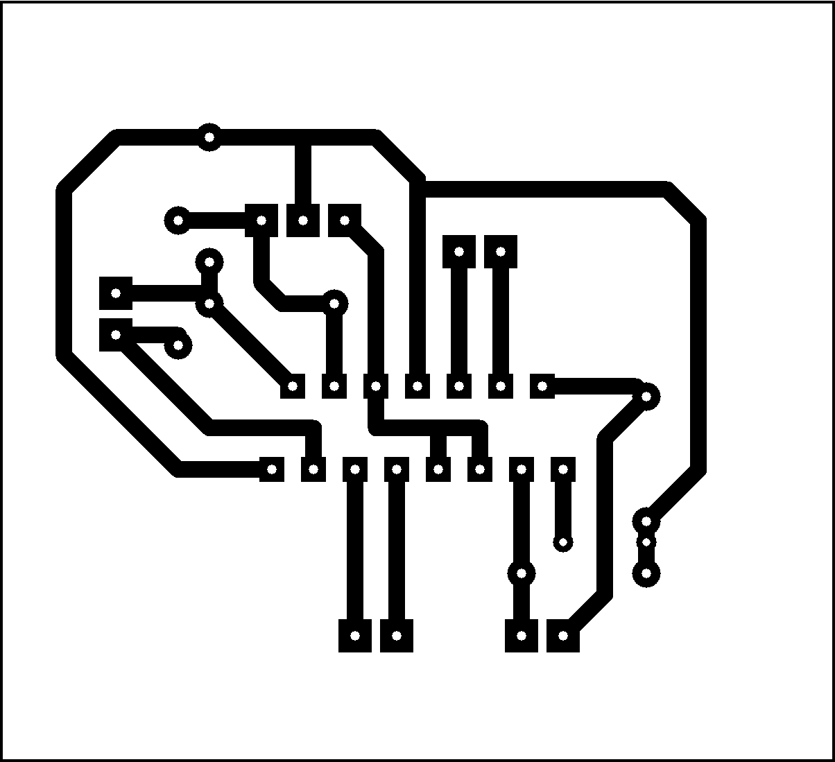

**Fig 3.6 PCB design of Motor Driver**

**3.5 Motors**

In this project we are going to need three DC motors. Two motors for driving the whole structure and remaining for handling the function of the arm. The design of arm is such that the required motion is achieved. To improve the precision level motors like servo can be used.

**3.5.1 DC Motor**

100 RPM Side Shaft Super Heavy Duty DC Gear Motor is suitable for bigger robots / small automation systems. It has sturdy construction with large gears. Gear box is built to handle the stall torque produced by the motor. Drive shaft is supported from both sides with metal bushes. Motor runs smoothly from 4V to 12V and gives 100 RPM at 12V. Motor has 8mm diameter, 19mm length drive shaft with D shape for excellent coupling.

Table below gives fairly good idea of the motor’s performance in terms of RPM vs voltage at no load and that of stall torque at different voltages.

**3.5.2 Specifications:**

* RPM: 100 at 12V
* Voltage: 4V to 12V
* Stall torque: 42.51 Kg-cm at stall current of 6.9 Amp.
* Shaft diameter: 8mm
* Shaft length: 25 to 30mm
* Gear assembly: Spur
* Brush type: Carbon
* Motor weight: 370gms

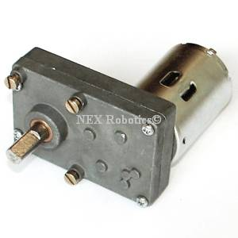

**Fig 3.7 DC Motor[9]**

**3.6 Mechanical aspects**

This contains all the mechanical aspects related with the robot.

**3.6.1 Aluminum chassis**

**Features:**

* Good axial load strength and also light weight.
* Faster production rate.
* Rate of failure is very less.
* Less finishing and shipping costs.
* Raw parts manufacturing costs are much less.
* Better looking parts.

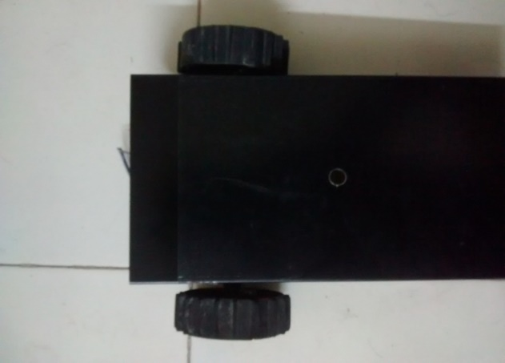

**Fig 3.8 Aluminum Chassis**

**3.6.2 Fork Lift arrangement**

One very important consideration in designing a lift is the amount of torque required, which depends on the weight to be lifted. It is important to keep length of the lift to a minimum, as torque increases as you increase distance from the weight to the pivot point. Even so, most lifts (including this one) need to be geared down, trading speed for increased strength.

Forklifts are either powered by gasoline, propane, or electricity. Electric forklifts are great for warehouse use because they do not give off noxious fumes like gas powered machines do. Various fields of technologies are included in this project work, because this system falls under the subject of Mechatronics. The integration of electronic engineering, mechanical engineering, electrical engineering, & control technology is forming a crucial part in this design.

**Advantages of Fork Lift arrangement:**

* Suitable for indoor use
* Longer life
* Minimum noise level
* Eco-friendly operation
* It can be used in hazardous areas.
* Huge advantage of forklift is that they have no fuel cost.
* The best electric forklift is that they have zero emission which causes safe and healthy environment. That is why they can be called the Green Forklift.
* The operation cost is low.
* The life of electric forklift is greater than other types.
* Maintain better control of material management
* Reduce product damages
* Reduce manpower
* Increase productivity
* Suitable to transfer frames

**Disadvantages of Fork Lift arrangement:**

The speed is low.The main disadvantage is the area should be properly dry and should have controlled temperature, otherwise you face accidents

**Chapter 4**

**Software Platform**

**4.1 Flowchart:-**

Flowchart gives the idea of the programming steps and execution. There are two flowcharts in this chapter. The programming for transmission and reception is slightly different thus two flowcharts are shown.

1. Flowchart for transmitter
2. Flowchart for receiver

Both flowcharts are shown below:

**Flowchart for transmitter:**

START

ACCEPT THE VALUES FROM ACCELEROMETER

PROCESS & SEND THE VALUES TO XBee TRANSMITTER

STOP

**Flowchart for Receiver:**

NO

m1=OFF, m2=ON

m1=ON, m2=OFF

m1=REV, m2=REV

m1=ON, m2=ON

IF STATE=D

NO

NO

NO

NO

YES

YES

YES

YES

IF STATE=C

IF STATE=B

IF STATE = A

YES

CHECK FOR READY STATE

PROCESS AND DETERMINE THE DESIRED STATE FOR m1 & m2

ACCEPT THE VALUES FROM XBee RECEIVER

START

**4.2 Programming in Arduino:-**

The Arduino Uno can be programmed with the Arduino software.

The ATmega2560 on the Arduino Uno comes pre-burned with a boot-loader that allows you to upload new code to it without the use of an external hardware programmer. It communicates using the original STK500 protocol (reference, C header files).

You can also bypass the boot-loader and program the microcontroller through the ICSP (In-Circuit Serial Programming) header using Arduino ISP.

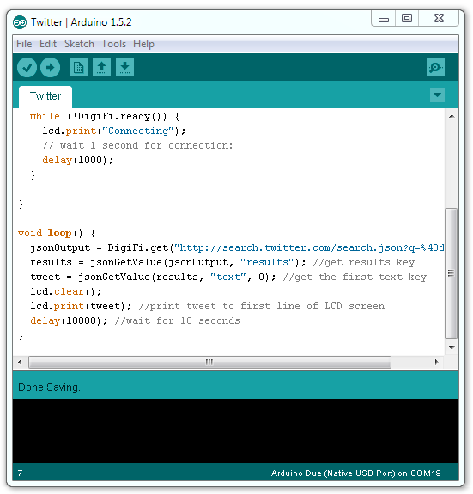

**Fig 4.1 Arduino User Interface[10]**

 It is very much easy to learn this software and implement the various applications. It has a user friendly UI that helps in developing the desired program.

**4.3 X-CTU Software:-**

The highlights of XCTU include the following features:

* XCTU is a multi-platform application compatible with Windows and MacOS systems.
* The tool has a renewed, fresh and intuitive UI.
* A new discovery mechanism allows you to automatically search for RF modules connected to your PC.
* You can manage and configure multiple RF devices, even remotely (over-the-air) connected devices.
* The firmware update process seamlessly restores your module settings, automatically handling mode and baud rate changes.
* Two specific API and AT consoles, have been designed from scratch to communicate with your radio devices.
* You can create your own sequence of API frames or data packets and send them or save them for future uses.
* You can now save your console sessions and load them in a different PC running XCTU.
* The tool gives you the ability to explore the topology of RF networks displaying all its nodes and connections graphically or in a table.
* XCTU introduces you to the Device Cloud platform which gives you the ability to to connect any device and communicate in two directions from anywhere.
* XCTU includes a set of embedded tools that can be executed without having any RF module connected:
  + Frames generator: Allows you to easily generate any kind of API frame to save its value.
  + Frames interpreter: With this tool you can decode an API frame and see its specific frame values.
  + Recovery: Allows you to recover radio modules which have damaged firmware or are in programming mode.
  + Load console session: This tool allows you to load a console session saved in any PC running XCTU.
  + Range test: Gives you the ability to perform a range test between 2 radio modules of the same network.
  + Firmware explorer: With this tool you can navigate through XCTU's firmware library.
* An update process allows you to automatically update the application itself and the radio firmware library without needing to download any extra files.
* XCTU contains complete and comprehensive documentation which can be accessed at any time.

**4.3.1 Toolbar:-**

[Toolbar](http://127.0.0.1:50472/help/topic/com.digi.xctung.doc/html/images/img001e.jpg)

The toolbar is located at the top and is divided into three different parts:

* The first part contains two icons used to add radio modules to the radio modules list.

Add modules

* The second part contains the XCTU static functionality. This is functionality that does not need a radio module to be executed. This part includes the XCTU tools, the XCTU configuration, the feedback form and the help and updates functions.

Static functionality

* Finally, the third part of the toolbar is a tabbed list which allows access to the different working modes of the tool and displays those modes in the working area. These functionality sets must have one or more radio modules added to the list in order to work properly.

Working modes

#### 4.3.2 Devices List:-

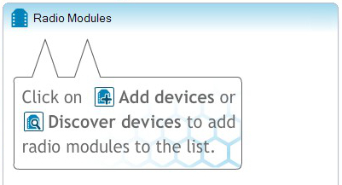

The radio modules list is located at the left side of the tool and displays the radio modules that are connected to your PC and which you can interact with. If you know the serial port configuration of a radio module, you can add it to the list directly otherwise you can use the discovery feature of XCTU to find radio modules connected to your PC and add them to the list.

Depending on the protocol of the local radio modules added, it is also possible to add remote radio modules to the list using the module's search feature.

**4.3.3 Working area:-**

[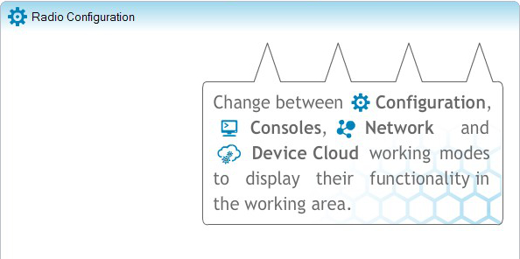](http://127.0.0.1:50472/help/topic/com.digi.xctung.doc/html/images/img001g.jpg)

The working area is the largest section, and is located at the right side of the application. The contents of the working area will change depending on the working mode selected in the toolbar. In order to interact with the controls displayed in the working area you must have one or more radio modules added to the list and one of them must be selected.

#### 4.3.4 Status Bar:-

Status bar

The status bar is located at the bottom of the application and displays the status of specific tasks, such as the firmware download process.

### 4.3.5 Application working modes

A working mode represents a layout which displays operations you can perform with a radio module. Usually, the working mode functionality is displayed in the working area. The tool has 4 working modes:

* Configuration mode: Allows you to configure the selected radio module from the list. For further information about this working mode.
* Consoles mode: Allows you to interact or communicate with the selected radio module. For further information about this working mode.
* Network mode: Allows you to discover and see the network topology of 802.15.4, ZigBee and DigiMesh protocols..
* Device Cloud mode: Allows you to learn about Device Cloud by Etherios platform, create an account and access your personal Device Cloud page. For further information about this working mode.

Only one working mode can be selected at the same time and, by default, the Configuration mode is selected when XCTU is started.

## 4.3.6 RF modules

A radio frequency (RF) module is a small electronic circuit used to transmit and receive radio signals on different frequencies. Among all the products Digi produces, there is a wide variety of RF modules that can be used to meet the requirements of almost any wireless solution. The most popular wireless products are the XBee RF modules, but Digi also has other RF modules to satisfy the strictest requirements from the customers (long-range, low-cost, etc.).

As described in the [hardware requirements](http://127.0.0.1:50472/help/topic/com.digi.xctung.doc/html/requirements.html#hardware) section, XCTU is compatible with Digi's XBee and XTend RF modules.

To open the XCTU configuration dialog box, click the Preferences button of the toolbar.

Preferences button

The configuration dialog should display.

The configuration section of XCTU allows you to configure some settings of certain features of the application.

To open the XCTU configuration dialog box, click the Preferences button of the toolbar.

Preferences button

The configuration dialog should display.

**CHAPTER 5**

**EXPERIMENTATION AND RESULTS**

**5.1 Working of Accelerometer**

Different hand gestures to make the robot move in specific direction are given below.



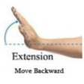

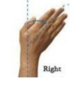

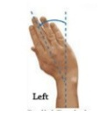

**Fig 5.1 Hand Movements[2]**

From the above figure, the robot moves in forward direction when the hand moves in downward direction. The robot moves in backward direction when the hand is in upward direction.Also the robot moves in right and left directions when hand movement is in right and left direction respectively.

Both accelerometers are mounted on two hands along with microcontroller and XBee transmitter. According to the movements of hands the microcontroller will take decisions of movements of robot. The XBee transmitter will transmit the data wirelessly to the XBee receiver on the robot.

**5.1.1 XBee transmitter readings**

|  |  |  |
| --- | --- | --- |
| X-axis range | Y-axis range | Hand movements |
| 325-330 | 251-407 | Left or Right |
| 253-403 | 323-327 | Upward or Downward |
| 300-350 | 300-350 | Steady |

**Table 5.1 XBee transmitter readings and hand movements**

**5.2 Transmission**

XBee S2 module is used as a transmitter. XBee transmitter sends the data signal from microcontroller to the XBee receiver. The readings of XYZ axes shown in table 5.1 are sent to the receiver wirelessly from the transmitter.

**5.3 Reception**

XBee S2 module is used as a receiver. XBee receiver receives the coming data from transmitter and gives it to the microcontroller on the robot.

**5.4 Motor Driver**

**5.4.1 Description**

The L298 is an integrated monolithic circuit in a 15-lead Multi watt and PowerSO20 packages. It is a high voltage, high current dual full-bridge driver designed to accept standard TTL logic levels and drive inductive loads such as relays, solenoids, DC and stepping motors. Two enable inputs are provided to enable or disable the device independently of the input

signals. The emitters of the lower transistors of each bridge are connected together and the corresponding external terminal can be used for the connection of an external sensing resistor. An additional supply input is provided so that the logic works at a lower voltage.

**5.4.2 Motor Driver Working**

The motor driver circuit receives instructions from microcontroller and set the direction of one or both the two motors in different cases. The different cases are discussed below:

* Case 1-Forward movement:- The motor M1(motor on the right side of the robot) and motor M2 (motor on the right side of the robot) both move in forward direction.
* Case 2-Backward movement:- The motor M1 and M2 both move in backward direction.
* Case 3-Right turn:-Motor M1 moves in backward direction and motor M2 moves in forward direction.
* Case 4-Left turn:- Motor M1 moves in forward direction and motor M2 moves in backward direction.

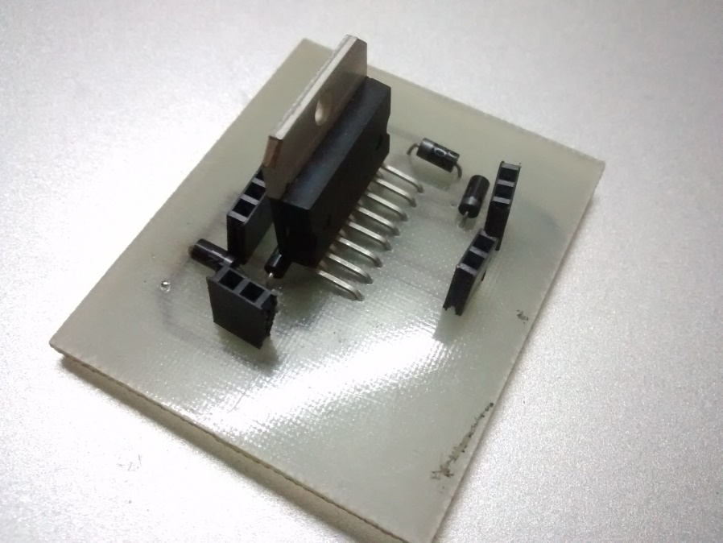

**Fig 5.2 Motor Driver PCB**

**5.5 Fork lift Working**

In general the forklift can be defined as a tool capable of lifting hundreds of kilograms of weight. A forklift is a vehicle similar to a small truck that has two metal forks on the front used to lift cargo.

Forklifts are important tools in contexts where there are a lot of heavy goods to be unloaded, unpacked, or stored. They are motorized vehicles that are usually only big enough to accommodate a single driver. The forklift gets its name from two fork-like tines that extend from its front. These tines are usually connected to a hydraulic lifting system that the driver can manipulate up and down.

Forklifts are indispensable in warehouses where large quantities of goods arrive by truck and must be unloaded, packed, and stored, often on very high shelves.Mini forklifts are usually miniature versions of full-sized forklifts. Most of the time, a mini forklift is operational to some capacity, but is not usually useful in a [warehouse](http://www.wisegeek.com/what-is-a-warehouse.htm) setting.

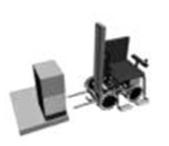

(a)

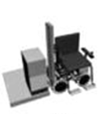

(b)

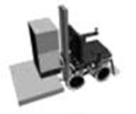

(c)

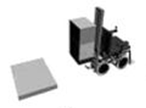

(d)

**Fig. 5.3 Working of Fork lift arrangement[1]**

In above figure following steps are discussed:

1. Robot moves towards the box to be picked up
2. Robot moves its forks under the box
3. Using lift, the robot lifts the forks to a certain height
4. Finally the robot picks the box and moves towards the destination.

**CHAPTER 6**

**CONCLUSION & FUTURE SCOPE**

**6.1 Conclusion**

The objectives of this project has been achieved which was developing the hardware and software for an accelerometer controlled robot. From observation that has been made, it clearly shows that its movement is precise, accurate, and is easy to control and user friendly to use. This robotic arm control method is expected to overcome the problem such as placing or picking object that away from the user, pick and place hazardous object in a very fast and easy manner. Based on the results, the objective of developing wireless mobile robot using Zigbee protocol has been achieved. Zigbee has been proven as a practical solution for low cost monitoring and controlling devices. The wireless communication technologies are rapidly spreading to many new areas, including the automation and the importance of the use of wireless technologies in the data acquisition, building control, monitoring systems and automation of manufacturing processes will grow.

Intelligent mobile robots and cooperative multi-agent:- Robotic systems can be very efficient tools to speed up search and research operations in remote areas. These robots are also useful to do jobs in areas and in situations that are hazardous for human. They can go anywhere that is not reachable by humans and can go into gaps and move through small holes that are impossible for humans and even trained dogs.

**6.2 Future scope**

As such, the scope of this project to demonstrate the successful wireless mobile robot navigation can be further improved. The next step is to build an autonomous robot, which is able to send the environmental status, the temperature condition, with smart obstacle avoidance system.

A robot is an “apparently human automation, intelligent and obedient but impersonal machine”. Basically, a robot is a machine designed to do a human job (excluding research robots) that is tedious, slow or hazardous. In future, we use this project is to design and develop an intelligence robot to detect dangerous Gas/Smoke. In our project, the robot is designed to move automatically. The robot acts according to the command given by the program. It will move all the direction like forward, reverse, right and left. The Smoke sensing unit is available in robot mechanism. If particular Smoke is detected, robot will switch ON the Alarm Unit. The video and audio are monitored at the control unit. For transmitting audio and video, RF camera has been used.

Inspired biocolonies of insects such as ant sandbees, researchers are modelling the behaviour of swarms of thousands of tiny robots which together perform a useful task, such as finding something hidden, cleaning, or spying. Each robot is quite simple, but the emergent behaviour of the swarm is more complex. The whole set of robots can be considered as one single distributed system, in the same way an ant colony can be considered as upper organism, exhibiting swarm intelligence. The largest swarms so far created include the iRobot swarm, the SRI/Mobile Robots Centi Bots project and the Open-source Micro-robotic Project swarm, which are being used to research collective behaviours.

Swarms are also more resistant to failure. Whereas one large robot may fail and ruin a mission, a swarm can continue even if several robots fail. This could make them attractive for space exploration missions, where failure can be extremely costly.

An interesting way to approach autonomous operation whilst realizing useful applications along the way is to devise the means by which humans can interact and intervene with robots which are richly sensor equipped, providing the missing capabilities such as subtle judgments, risk analysis, fine dexterity and reaction to unpredicted events but in such as way that a continuum between full autonomy and full teleoperation can be smoothly engaged. As the technology matures, the human support can be gracefully withdrawn with less and less intervention over more and more of the tasks. For example there are many situations in, say, fire fighting where a robotic vehicle carrying water may move along a fire front spraying water at hot spots detected using a thermal camera fairly autonomously, but a human may need to direct the vehicle to move to another more critical, fire front or assist in a delicate rescue mission under direct teleoperational control. As another example, a transport vehicle may safely negotiate a highway navigation task, changing lanes and speed as required, replanning routes and so on, yet a human operator may need to take over at an unexpected construction site or scene of an accident.

The main challenges for the future of intelligent robotics are:

1. Improvements of the quality, robustness, smaller size and reduced cost of camera, laser range, ultrasonics, radar, and inertial sensors.

2. Improvements in computational power at low cost. This aspect will not need any special attention because of existing market forces.

3. Improvement in mechanisms for robot platforms in terms of weight, strength, and capability and the use of new materials, including ceramics, carbon fibre, titanium etc.

4. Improvements in navigation algorithms including natural landmark based approaches, recovery mechanisms, accommodation of varying cost structures related to navigability, collision risk, visibility etc.

5. Improvements of Human/Machine cooperation, including communication, task refinement, intervention etc.

6. Improvement in risk assessment and endurance in terms of operational times and graceful degradation.

7. Clarification of legal aspects of humans and robots working together.

8. Better understanding of emotional aspects of robots working with humans.

9. Evolution of the robot/biology cross-inspirational trend.

10. Development of robotic ethics.

**6.3 References**

[1] RK Mittal and IJ Nagarath “Robotics and Control” BITS Pilani, 2003

[2] Ratheesh Rajan “Studies for an Alternate Approach to handle industrial storage systems” M.S.E., the University of Texas at Austin, 2001

[3] Richard E. Pattis. *Karel the Robot: A Gentle Introduction to the Art of Programming*. John Wiley & Sons, 1981.

[4]Nam Sun Wang, Department of Electronics & Telecommunication Engineering, University of Maryland.

**Websites**

[5] www.robotics.com

[6] [www.asmedl.org/robotics](http://googleads.g.doubleclick.net/aclk?sa=l&ai=BLN-3JivhTNL3B8q9cPiQjYIP1afj9gHFnOL7GMCNtwHg1AMQBBgEIJ-OggIoDjgAUJnhlW5g5Yrlg6gOoAHt9d_-A7IBDnd3dy5idXp6bGUuY29tyAEB2gEzaHR0cDovL3d3dy5idXp6bGUuY29tL2FydGljbGVzL3R5cGVzLW9mLXJvYm90cy5odG1sqAMB6AP1COgD6AQ&num=4&sig=AGiWqtzZG4toL3DOpzBzCh2WwNxHXhzyWw&client=ca-pub-9037304895410090&adurl=http://www.asmedl.org/jmr)

[7] <http://www.robologix.com>

[8] [www.seattlerobotics.org/encoder/aug97/basics.html](http://www.seattlerobotics.org/encoder/aug97/basics.html)

[9] www.nexrobotics.com

[10] www.arduino.cc

[11] http://www.digi.com/support

[12]http://www.engineersgarage.com/electronic-components/rf-module-transmitter-receiver